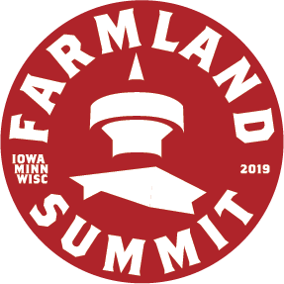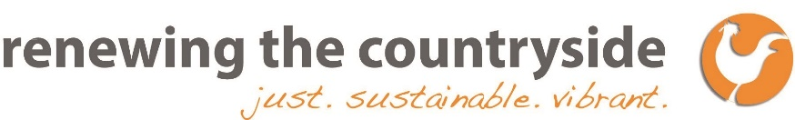
For Immediate Release
Media Contact: Pam McCarthy-Kern, 612-360-0647, pam@becausecollective.com
Agriculture Thought Leaders, Policymakers, Farmers and Other Experts to Convene in Minnesota to Discuss Strategies and Innovative Solutions to Address the Plight of Family Farms and the Future Viability of Rural Communities
Minneapolis, MINN. (October 8, 2019) – The National Agricultural Statistics Service estimates that over the next five years nearly 100 million acres of U.S. farmland are expected to change ownership, and the American Farmland Trust’s research shows that 371 million acres—more than 40 percent of American farmland and ranchland—will change hands over the next 15 years. These numbers might suggest that farmland is easily accessible for new farmers, yet in 2017, a National Young Farmers Coalition survey of more than 3,500 young farmers and ranchers across the country found that, regardless of geography or whether they had grown up on a farm, land access was their number one challenge. These sobering realities are threatening the future viability of family farms and rural communities, and the security and strength of regional food systems and economies.
On October 21, agriculture thought leaders, policymakers, change agents, and seasoned farmers from around the U.S. will convene in Red Wing for the Upper Midwest Farmland Summit, to address these issues and discuss innovative strategies and solutions to help farmers successfully transition their farms both within and outside the family, and to assist beginning farmers to attain affordable land access and tenure. The Upper Midwest Farmland Summit is presented by the Farmland Access Hub which is an initiative that assists beginning farmers in Minnesota, Wisconsin and Iowa in accessing farmland, securing land tenure, developing basic literacy about what they should consider and how to be prepared, and providing specialized knowledge, expertise and connections. Participants working with the Farmland Access Hub, an initiative of Renewing the Countryside and two dozen program partners, work with a team of Farmland Access Navigators in coordination with attorneys, real estate professionals, financial experts, and seasoned farmers.
More farm families equates to stronger rural communities and a more robust agricultural system. Immediate action is needed to preserve and grow the number of small and mid-sized family farms. Here are a few statistics about Minnesota, Iowa and Wisconsin, though these scenarios are happening in rural communities across America (sources are USDA NASS, Iowa State Farmland Values Survey, Wisconsin Department of Agriculture, Trade and Consumer Protection and MN Land Economics).
- Iowa farmland is three times more expensive now than in 1990.
- In Minnesota, land availability has decreased by almost 70 percent in less than 30 years.
- Wisconsin lost 551 dairy farms in 2019, 638 in 2018, and 465 in 2017.
Following the Upper Midwest Farmland Summit, Renewing the Countryside will host the fourth annual National Farm Viability Conference in Red Wing from October 22-24. The Conference is a gathering of professionals in the fields of farm and food business planning, agricultural financing, farmland conservation, agricultural market development, and food hub management. It will feature three days of workshops, discussions and tours focused on strengthening farm sustainability, building more resilient local food systems and supporting the long term profitability of farming and agri-entrepreneurs, from start-ups to generational businesses. Attendees will have the opportunity to network and learn from industry leaders and other professionals in their fields, develop new knowledge and skills, and tour nearby farms and value-added processing facilities. This is the first time the Conference has been held outside of the East Coast.
For more information about the Upper Midwest Farmland Summit, visit www.renewingthecountryside.org/farmlandsummit.
For more information about the National Farm Viability Conference, visit www.renewingthecountryside.org/nfvc.
About Renewing the Countryside:
Renewing the Countryside empowers people and communities to advance ideas and efforts that contribute to economic, social, and environmental wealth in rural places. The nonprofit organization accomplishes these goals by sharing stories of rural renewal, building awareness and support for sustainable endeavors, connecting people interested in sustainable rural development to each other, providing practical assistance and networking opportunities for those working to improve rural America, and fostering connections between urban and rural people.
About Farmland Access Hub:
The Farmland Access Hub is an initiative of Renewing the Countryside and nearly two dozen partners to address the farmland access challenges facing beginning farmers in Minnesota, Wisconsin, and Iowa. The program is funded by the USDA and assists new farmers in accessing farmland, securing land tenure, developing basic literacy about what they should consider and how to be prepared when, and providing specialized knowledge, expertise and connections. www.renewingthecountryside.org/farmlandaccess
# # #

